Department of Plant Sciences Timeline

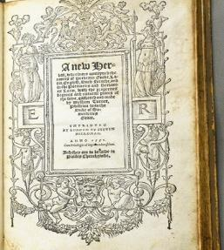
1500s
William Turner, ‘the father of English botany’, began botanical teaching and research in Cambridge. Turner’s New Herball of 1551-68 records the botanical features of 238 plants native to England, and marks the beginning of UK plant systematics and taxonomy.
Image credit: Turner’s New Herball, from the collection of John Martyn (second Professor of Botany). Andrew Benton. Cambridge University Library.

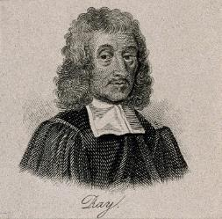
1600s
John Ray began to develop Botany at Cambridge. He searched the University for someone to instruct him, ‘But, to my astonishment, among so many masters of learning and luminaries of letters I found not a single person who was deeply versed in Botany… so why should not I, endowed with ample leisure, if not with great ability, try to remedy this deficiency…?’ Ray subsequently published the first flora of Cambridgeshire (1660) and England (1670).
Image credit: John Ray. Line engraving after Mary Beale. Wellcome Collection. Public Domain Mark.

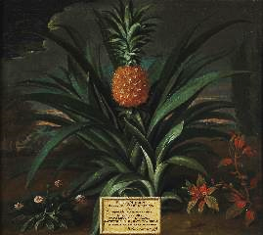
1724
Richard Bradley became first Professor of Botany at the University of Cambridge. He was elected to the Royal Society at the age of twenty-four. Research included a substantial analysis of succulent plants, as well as analysis of tulips and auriculas that influenced our understanding of plant reproduction. Known for his New Improvements in Planting and Gardening (1717-18), one of the first works on horticulture, he was the first to publish recipes in the English language using the then-exotic pineapple as the main ingredient (such as ‘a Tart of the Ananas, or Pine-Apple’).
Image credit: Theodorus Netscher, Pineapple grown in Sir Matthew Decker's garden at Richmond, Surrey, 1720. Fitzwilliam Museum. CC-BY-NC-ND.

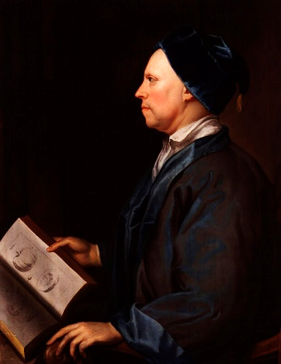
1733
John Martyn appointed the as second Professor of Botany, and was also elected to the Royal Society. His Historia Plantarum Rariorum (1728-37) is of particular interest as it contains some early examples of colour printing from a single metal plate. Martyn was an acquaintance and regular correspondent of Hans Sloane (whose collections would later form the basis of the British Museum and Natural History Museum London), Joseph Banks, and Johann Jacob Dillenius, and his Hortus siccus (lit. dried garden) formed the basis of the University Herbarium.
Image credit: John Martyn, Unknown artist, National Portrait Gallery, London. CCBY-NC-ND.

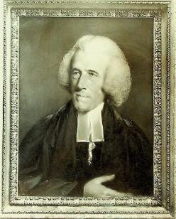
1762
Thomas Martyn FRS succeeded his father as the third Professor of Botany. He founded the original Cambridge University Botanic Garden (on what is now the New Museums site), along with the benefactor Richard Walker, which became an early site for experimental botany where ‘trials and experiments’ would be ‘regularly made and repeated’ in order to discover the virtues of plants ‘for the benefit of mankind’.
Image credit: Thomas Martyn. John Russell’s pastel portrait. Department of Plant Sciences, University of Cambridge.

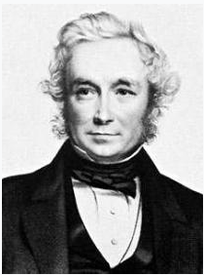
1825
John Stevens Henslow was elected as the fourth Professor of Botany. With his knowledge also of entomology and mineralogy he encompassed much of natural history.
The Botanic Garden was re-founded by Henslow at its current site, on the academic principle of being provided for the study of plants themselves (rather than as a physic or economic garden). In addition, the trees, around which the collection was designed, were planted in groups to demonstrate variation within species, species and their hybrids, and mutations (or ‘monstrosities’, as Henslow referred to them).
Henslow’s herbarium specimens also record his fascination with variability and discontinuity within and between species; this approach formed a crucial influence on his most famous pupil, Charles Darwin.
Image credit: John Stevens Henslow, T.H. Maguire, U.S. National Library of Medicine. CC.

1831
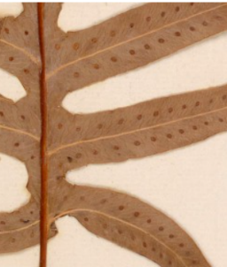
It was Henslow who recommended to Robert Fitzroy, captain of HMS Beagle, that Darwin join as the expedition’s naturalist. This led to the two-year voyage to survey South America aboard the ship HMS Beagle. Darwin’s natural history specimens from the Voyage were sent to his mentor back in Cambridge – and Henslow incorporated nearly 1,000 of the botanical specimens into the Herbarium, where they remain today. Documenting the plants encountered and observed on the Voyage – and importantly where and when they were collected – Darwin’s specimens formed part of the empirical evidence underpinning his theory of evolution by natural selection.
Image credit: Phelebodium areolatum (Humb. & Bonpl. ex Willd.) J. Sm. Collected by Charles Darwin, Galapagos; S. Amer: James Island. October 1835. Cambridge University Herbarium (CGE).

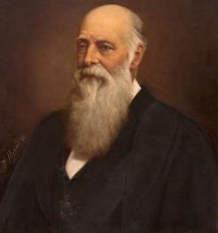
1861
Charles Cardale Babington was appointed as the fifth Professor of Botany. He wrote the Manual of British Botany (1843), Flora of Cambridgeshire (1860), The British Rubi (1869), and edited the publication Annals and Magazine of Natural History from 1842. His contributions were recognized through elections to the Botanical Society of Edinburgh, the Linnean Society of London, the Geological Society of London, and the Royal Society.
Image credit: Charles Cardale Babbington, Worthy Vizard, Department of Plant Sciences, University of Cambridge.
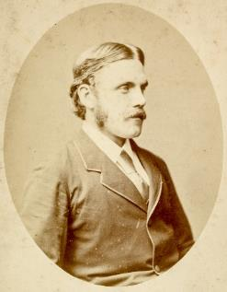

1884
Francis Darwin FRS, the third son of Charles, was appointed a lecturer (later Reader) in Botany. Francis was at the spearhead of the transition of British plant sciences from a purely systematic study, to one that encompassed plant physiology. His work on light signalling, particularly phototropism and the regulation of stomatal movements, was groundbreaking. He is probably best remembered for his 1894 class laboratory manual book “The Practical Physiology of Plants” that remained in widespread use into the 1920s.
Image credit: Francis Darwin. MS DAR 225: 42. Cambridge University Library.
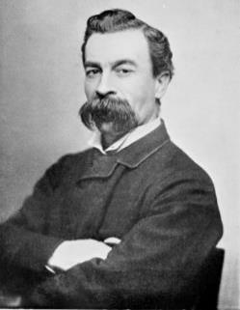

1895
Harry Marshall Ward FRS became the sixth Professor of Botany. Prior to this, he was employed by the British government in then Ceylon (Sri Lanka) to study a major disease affecting the island's coffee plantations. His recommendations included avoiding monoculture, cultivating multiple strains of coffee, and growing trees between plantations to reduce the spread of disease spores on the wind.
Image credit: Harry Marshall Ward. Wiki Commons.

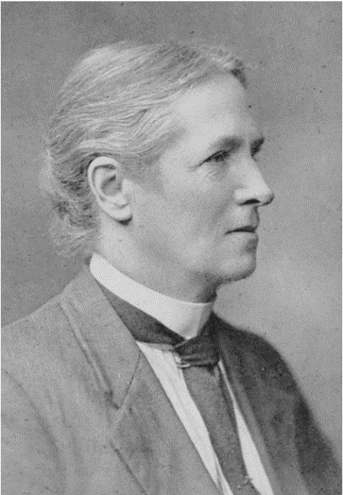
1902
Edith Saunders, a pioneering geneticist, was research active to 1940, although never a member of staff (she was a Fellow of Newnham College, having graduated when women were unfortunately still not admitted fully to University courses). Together with William Bateson (who was to become the first Director of the John Innes Horticultural Institute) they introduced the now familiar terms allele, heterozygote, homozygote, F1 and F2. She became one of the first women Fellows of the Linnean Society. She was appointed a fellow of the Royal Horticultural Society, received the Banksian Medal, and elected to the Linnean Society of London.
Arthur George Tansley founded the New Phytologist prior to starting as a Lecturer in the department, and served as editor until 1931. He is remembered for his introduction of the term ‘ecosystem’, and later became the first president of the British Ecological Society.
Image credit: Edith Saunders. Department of Plant Sciences, University of Cambridge

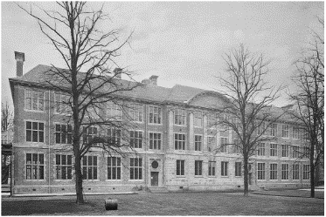
1904
The Botany School building, now known as the Department of Plant Sciences, was opened on 1 March 1904 by King Edward VII and Queen Alexandra, complete with a seven-course lunch. Marshall Ward designed and equipped the building to his own requirements. He was inspired by development of experimental techniques to study plant biology, particularly in Germany, and wanted there to be suitable laboratories for the experimental analysis of plant life.
Image credit: Botany School, 1904. Department of Plant Sciences, University of Cambridge.
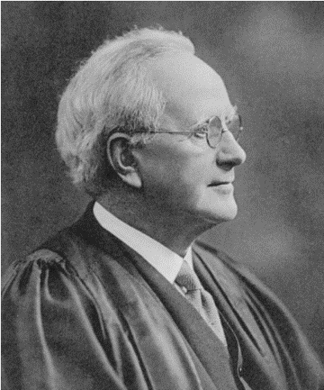

1906
Albert Seward was appointed the seventh Professor of Botany. In 1898, at the age of 35, he had been elected as a Fellow of the Royal Society for his studies of Mesozoic palaeobotany.
Image credit: Albert Seward. Department of Plant Sciences, University of Cambridge

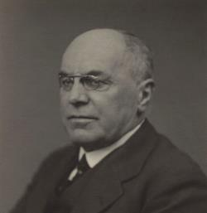
1936
Frederick Tom Brooks CBE, FRS became the eighth Professor of Botany. He specialized in mycology. During the First World War he was a plant pathologist in the Department of Food Production.
Image credit: Frederick Tom Brooks. Walter Stoneman. National Portrait Gallery. CC-BY-NC-ND.

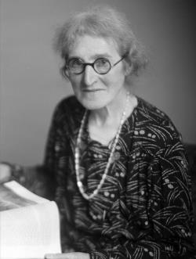
1946
Agnes Arber became the third woman to be elected as a Fellow of the Royal Society. She worked first in Newnham College, and then her house in Cambridge, but was never a member of staff of the University. Her contributions were widespread and recognized in many ways, but included analysis of water plants and monocotyledons, as well as being expert on plant morphology and herbals.
Image credit: Agnes Arber. Walter Stoneman. National Portrait Gallery. Editorial and non-profit social media license.

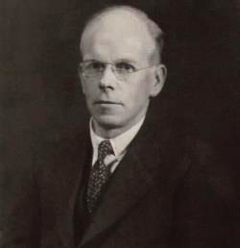
1948
George Edwards Briggs FRS was appointed Professor of Botany, and whose work primarily focused on enzymes. In retirement Briggs wrote the characteristically dense but insightful Movement of Water in Plants.
Image credit: George Edwards Biggs. Walter Stoneman. National Portrait Gallery. CC-BY-NC-ND.

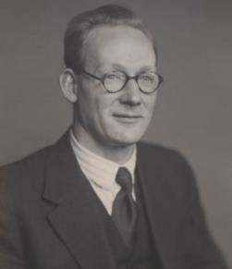
1960
Harry Godwin FRS became the tenth Professor of Botany. An influential peatland scientist, he coined the phrase ‘peat archives’ in 1981. He looked to integrate archaeological knowledge with new scientific techniques in geology and plant sciences and established one of the first 14C-dating labs in the world, and also founded and directed what became a sub-department of Quaternary Research. His achievements were recognised when he was knighted in 1970.
Image credit: Harry Godwin. Walter Stoneman. National Portrait Gallery. CC-BY-NC-ND.

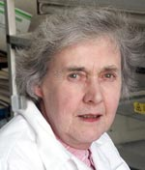
1963
Enid MacRobbie appointed a demonstrator. Enid was a pioneer in the new field of biophysics, went on to make many seminal discoveries in plant electrophysiology, and was notable for training illustrious alumni who populated research laboratories across the globe. Enid’s huge impact was recognised by a personal chair in 1987, making her the first woman scientist to receive this accolade at Cambridge, and was appointed a Fellow of the Royal Society of London as well as a member of the National Academy of Sciences (USA). Enid was also the first female Acting Head of the Department of Plant Sciences.
Image credit: Enid MacRobbie. Department of Plant Sciences, University of Cambridge.
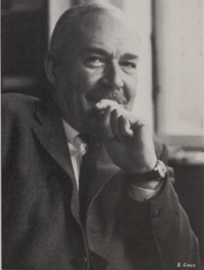

1968
Percy Wragg Brian FRS was appointed Professor of Botany. Prior to his role in the Department, whilst at the Jealott’s Hill and Akers Research Laboratories of Imperial Chemical Industries Ltd in 1936–63, he and his colleagues were responsible for the discovery of many different antibiotics, and for establishing their role in the soil microbial system. Of particular importance was his work on griseofulvin, used to treat mycoses (fungal infections) of humans and domestic animals. By 1980 one million patients had been treated with it, and global consumption was worth £25m per year.
Image credit: Percy Wragg Brian. Bertl Gaye. Royal Society.
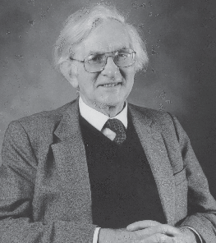

1977
Richard Gilbert West FRS became Professor of Botany, and was known for studying the changes that occurred during periods of ice cap retreat in Britain. He found species respond individually to environmental factors rather than as tightly knit sets of species called ‘communities’, and that some plant species were slow to migrate.
Image credit: Richard Gilbert West. Department of Plant Sciences, University of Cambridge.

1991
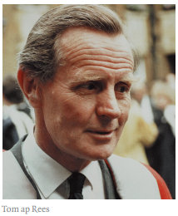
Tom ap Rees appointed Professor of Botany. His contribution to plant biochemistry was substantial, publishing over 100 research papers and more than 20 reviews during his career. A vast array of his PhD students became influential in various fields of Plant Biochemistry.
Image credit: Tom ap Rees. Department of Plant Sciences, University of Cambridge.

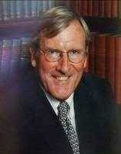
1998
Roger Allen Leigh appointed as Professor of Botany. Prof Leigh, a plant electrophysiologist who trained with Professor Enid MacRobbie, began a program of modernisation in the Department. He oversaw complete refurbishment of the Botany School research and teaching laboratories, and his tenure saw the recruitment of several new staff. He initiated the development of the Plant Growth Facilities at the Botanic Garden, which greatly enhanced the potential for careful physiological and genetic studies.
Image credit: Roger Allen Leigh. Department of Plant Sciences, University of Cambridge.

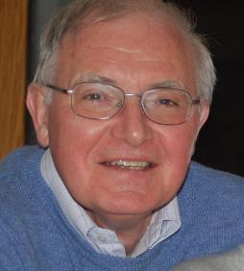
2004
John Gray appointed Head of Department. John Gray was an early adopter of molecular biology to understand plant biology, and made significant contributions to our understanding of chloroplast biogenesis and photosynthesis gene expression. He was instrumental in helping the Sainsbury Laboratory Cambridge University to be established, supported by the Gatsby Charitable Foundation, at the time representing the largest donation ever to the University.
Image credit: John Gray. Department of Plant Sciences, University of Cambridge.

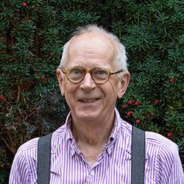
2007
David Baulcombe FRS appointed Professor of Botany. With Andrew Hamilton he discovered the small interfering RNA that is the specificity determinant in RNAmediated gene silencing, and demonstrated that while viruses can induce gene silencing, some viruses encode proteins that suppress gene silencing. In 2009
Baulcombe was knighted for his ‘services to plant sciences’. Her Majesty Queen Elizabeth II bestowed the title Regius Chair to the Chair of Botany in recognition of Professor Baulcombe’s contribution to plant biology.
Image credit: David Baulcombe. Department of Plant Sciences, University of Cambridge.

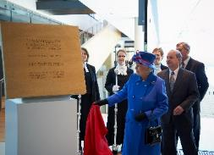
2011
The Sainsbury Laboratory Cambridge University (SLCU) opened by Her Majesty Queen Elizabeth II. The SLCU is a research institute funded by the Gatsby Charitable Foundation within the School of Biological Sciences, focused on increasing understanding systems underlying plant growth and development. SLCU is housed in a signature laboratory building on the Botanic Gardens site, and in 2012 won the RIBA Stirling Prize for architecture.
The Cambridge University Herbarium is rehoused in modern specialist facilities in the SLCU building, restoring our living and dead plant collections to one site at the Botanic Gardens for the first time in centuries.
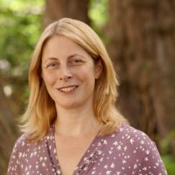
Image credit: Opening of Sainsbury Laboratory University of Cambridge by Queen Elizabeth. Nigel Luckhurst. Sainsbury Laboratory Cambridge University.

2013
Beverley Glover becomes the first female Director of the Cambridge University Botanic Garden.
Image credit: Beverley Glover. Cambridge University Botanic Garden.
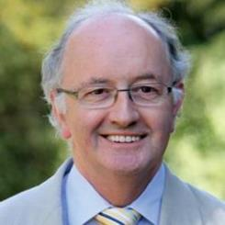

2015
Chris Gilligan awarded a CBE for ‘services to plant health in the field of epidemiology’.
Image credit: Chris Gilligan. Department of Plant Sciences, University of Cambridge.

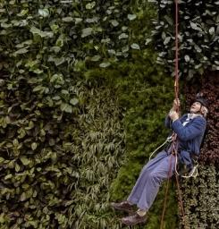
2016
The Cambridge Conservation Research Institute opened by David Attenborough, housing university researchers, including from the Department of Plant Sciences, with nine national and international conservation organisations. Together, the partners represent the largest cluster of conservation organisations in the world, seeking to transform the global understanding and conservation of biodiversity.
Image credit: Sir David Attenborough. Toby Smith. Cambridge Conservation Research Institute.

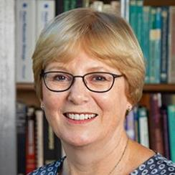
2017
Alison Smith becomes the first elected female Head of Department of the Department of Plant Sciences.
Ottoline Leyser was appointed Dame Commander of the Order of the British Empire for ‘services to plant science, science in society and equality and diversity in science’.
Image credit: Alison Smith. Department of Plant Sciences, University of Cambridge.

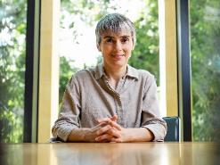
2020
Dame Ottoline Leyser FRS became the 16th, and first female, Professor of Botany, in the same year as becoming the first Chief Executive of UK Research and Innovation (UKRI).
The Crop Science Centre (CSC), an alliance between the Department of Plant Sciences and NIAB designed to fast-track technologies to sustainably improve farmers’ yields worldwide, opens. The CSC is housed in new laboratory space on Huntingdon road under the leadership of Professor Giles Oldroyd FRS.
Image credit: Ottoline Leyser. Mike Thornton. Sainsbury Laboratory Cambridge University.
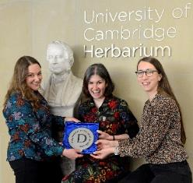

2022
The Cambridge University Herbarium was awarded Designated status by the Arts Council England, recognising its natural history collections as being of great historical and scientific importance for the country.
Image credit: Cambridge University Herbarium staff. Andrew Benton. Department of Plant Sciences, University of Cambridge.

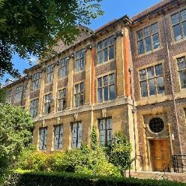
2024
The Department of Plant Sciences celebrates 300 years since the first Professor of Botany was appointed, and also 120 years of being in the Botany Building on the Downing Site. As part of the celebrations this year, we will be publishing monthly research stories highlighting some of the exciting research happening in this space at the University.
Image credit: Department of Plant Sciences, 2023. Katherine Maltby, Department of Plant Sciences, University of Cambridge.

