Research Fellowship Open Day
Department of Plant Sciences, University of Cambridge

We welcome approaches from candidates who are thinking of applying for independent Fellowships, such as Royal Society University Research Fellowships, BBSRC Discovery Fellowships, NERC Independent Research Fellowships, European Research Council (ERC) Starting Grants or EU Marie Skłodowska-Curie Action awards. The Department has an excellent tradition for supporting Research Fellows in terms of providing financial support for laboratories and equipment, and PhD studentship opportunities, as well as promoting career development and collaborative expertise.

The Department of Plant Sciences in Cambridge is one of the foremost centres to carry out research in plant science, with world-leading groups across the breadth of the subject from genetics and epigenetics, through plant physiology and biochemistry, to epidemiology and remote sensing at the landscape scale. The Department has five strategic targets: enhancing production of plant-derived products; reducing agricultural inputs; cutting loses from pests and pathogens; enabling resilience to environmental change; and delivering sustainable, bio-diverse landscapes. It also hosts the Plants@Cambridge initiative which aims to put plant research into practice.

The Department has 23 academic staff leading active research groups, 8 research fellows, 8 senior research associates, 71 post-doctoral researchers, 75 support staff and over 100 graduate students. Research grant income in 2021/22 was £16m, with the Department currently administering a total of 125 grants with a combined value of £119m from a variety of sources including Research Councils, Royal Society, EU, charities, industry and government agencies.

Excellent candidates for 2024 Fellowship schemes are now invited to apply to attend our Research Fellowship Open Day on 7th February 2024. Shortlisted applicants will be invited to visit the Department on 7 February to discuss their proposal/ application with members of staff. We will then select applicants from those shortlisted to support and mentor through the application process.

Successful Fellows will be provided with office and lab space, and resources for research including access to PhD studentships, plant growth facilities and glasshouses, and high-performance computing and imaging facilities.

Applicants should send the completed pro forma below, including a short summary (200 words maximum) of their proposed research topic, and their CV, highlighting their top 5 publications, to researchfellows@plantsci.cam.ac.uk by 1st December 2023. The University is a signatory to the Declaration on Research Assessment (DORA); we will not assess your journal or citation metrics, so please do not include these in your CV.

We welcome applications from individuals who wish to be considered for part-time working or other flexible working arrangements.

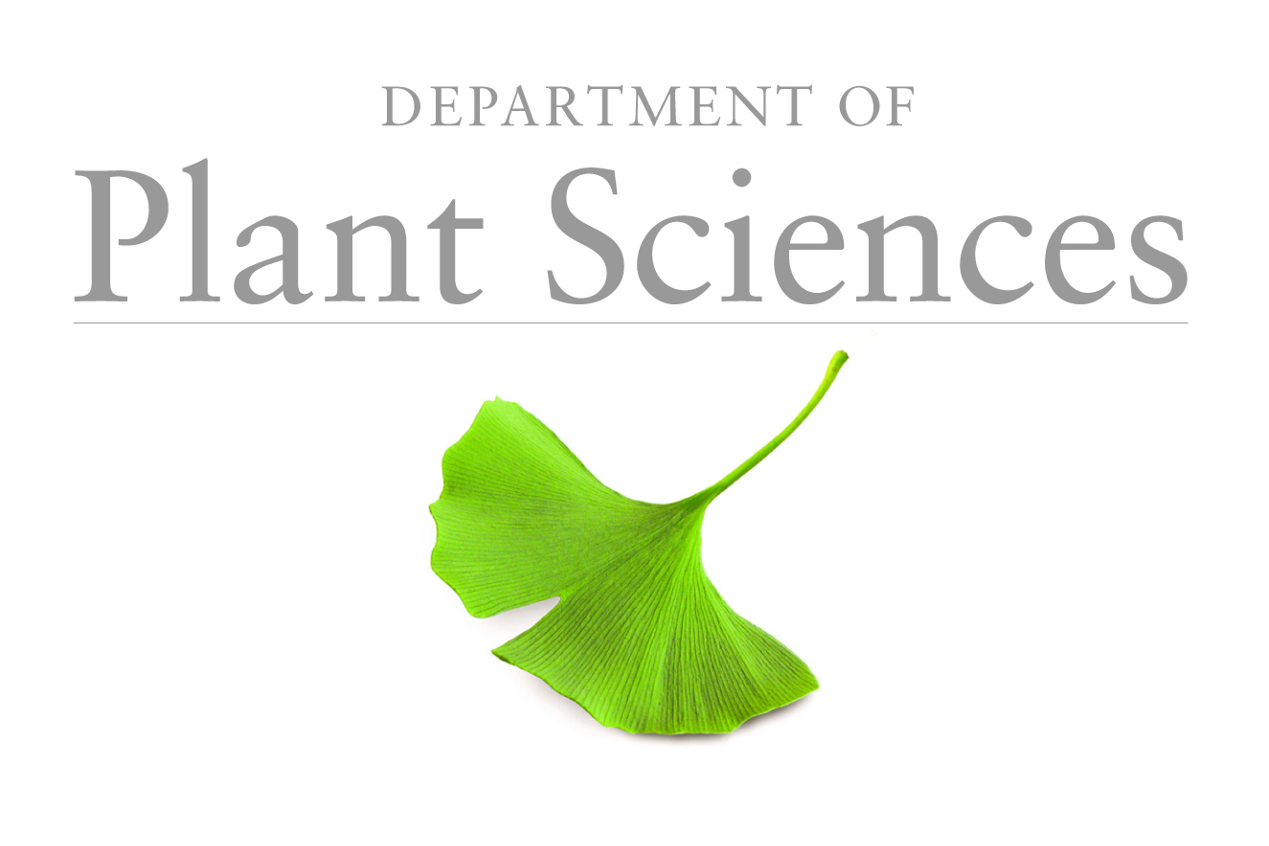 | UNIVERSITY OF CAMBRIDGE  DEPARTMENT OF PLANT SCIENCES  DOWNING STREET . CAMBRIDGE . CB2 3EA . ENGLAND  Reception: 01223 333900 Email: info@plantsci.cam.ac.uk

Proposed Research Fellow

Surname: First name: Title:

Proposed scheme and length of Fellowship:

Current University/ Institute address:

Proposed research topic (200 words or less):

Motivation to undertake a Fellowship in the Department of Plant Sciences:

Name of Academic Host (if appropriate):

